talkMail – Voice based Email Application

User Manual

W. M. I. B. Boyagane.

160071X

1. Before using the application, user need to have;

* A Gmail account with settings to have less secure apps to access. Click [here](https://support.google.com/accounts/answer/6010255?hl=en) for support.

1. Before start running the app, user need to have an internet connection.

**How to use**

1. User need to double click the Application.exe to start the app.
2. After starting the app, User will be provided some instructions to use the app.
3. Then, app will request user’s Google credentials in a sign in window.

* You can have a trusted third party to submit your Google credentials.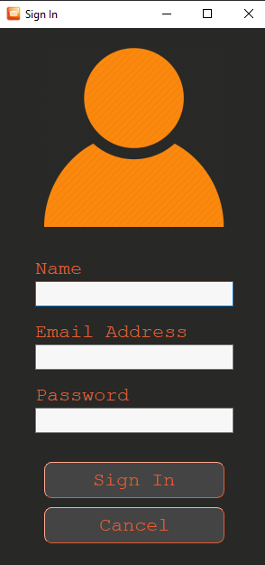
* In the “Name” field specify the name user want to appear in the closure of an email user send.
  + After specifying all fields, user can click “submit” button.
* If user want to cancel and leave the app user can click “Cancel”
* If the credentials are incorrect user is supposed to enter the credentials again until user succeed.
* If user close the app by closing the window he/she will leave the app and have to sign in when rerun the app.
* User do not have to sign in again and again once signed in.

1. If user have successfully submitted credentials main window appears.

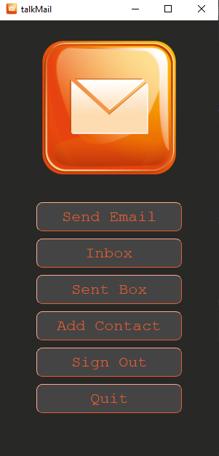

* When a button in this window is focused a voice note about that button is played.
* User is asked to press “space” and proceed to the required option when the required button is focused.
* Otherwise user can press tab and navigate the window until his/her the button of his need is focused and its voice note is played.
* Example: User need to read the inbox.
* First “Send Email” button is focused. (voice note saying “press space to send email, otherwise press tab” is played)
* User can press tab key.
  + - * “Inbox” button is focused. (voice note saying “press space to read received email, press tab otherwise” is played)
      * User can press space and proceed.

1. Sending email.

* When user starts to send email, this window appears.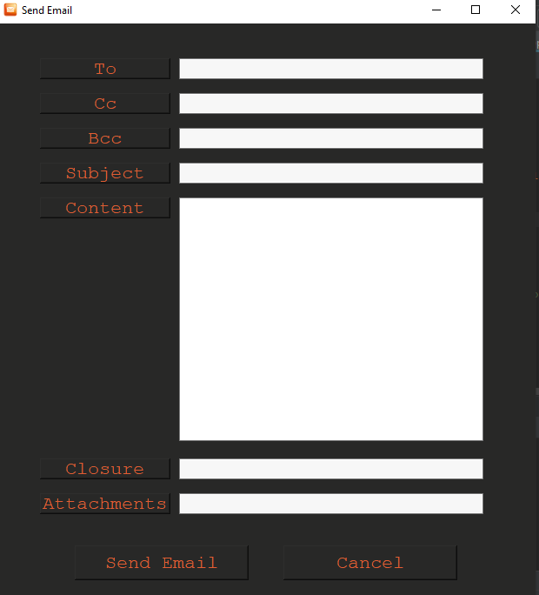
* By pressing buttons (after listening to the voice note about that particular button) in the left-hand side, user can start specifying fields.
* After user is done entering the field the content user specified is displayed and the next button is focused and voice note about that field is played so that user can decide proceed or not to specifying that particular field.
* When specifying the to/cc/bcc recipients user need to specify the keyword of the recipients so the email address of the particular recipient is automatically selected.
* If user is troubling with speech inputs user can withdraw from speech inputs by pressing “end” key and let user who can interact with GUI to allow use keyboard.
* When adding attachments user can proceed to file system by pressing “Attachments” button. Third party who can navigate in the file system can choose a file to attach. User can repeat this to add more file as attachments.
* After user specify all the fields he/she required user can proceed to send email button. (voice note is played). User can press space and send the email.
* Otherwise, user can cancel the sending.

1. Reading email.

* When user proceed to read “Inbox/Sent Box” given window appears. Latest sent/received email is displayed and audio of the content is played after opening the window.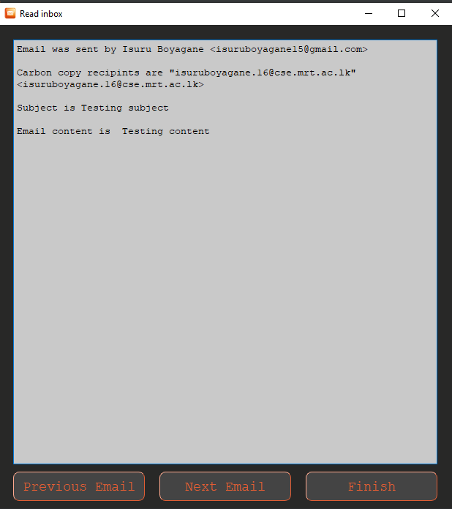
* User can press “end” key to terminate the audio playing and proceed to read previous email. Otherwise after finishing audio playing user is directed to read previous emails.
* When user press “previous email” previous email is displayed and played.
* If the current email is the latest email user is directed to read “next email”.
* If user wants to finish reading “Inbox/ Sent Box” user can press space to “Finish” button and go to main menu.

7.Adding Contact.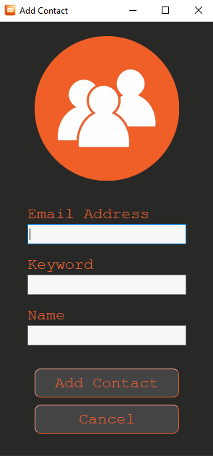

* When user wants to add a email address, keyword pair to the system, user can choose “Add Contact” in main menu.
* Third party who can interact with a GUI can enter the email address and correspondent keyword which is taught to the blind user.
* After user enter all required fields user can press “Add Contact” and submit them.
* If email address in invalid or keyword is already taken user is request to add the contact again.
* If user want to cancel adding contact user can press “Cancel”.

8. User Can terminate the application at any time by pressing “esc” key. then user is requested to press “esc” to confirm termination. Otherwise user can press any other key and proceed.